**14 Picture Books about Building with Blocks, Engineering, and Architecture**

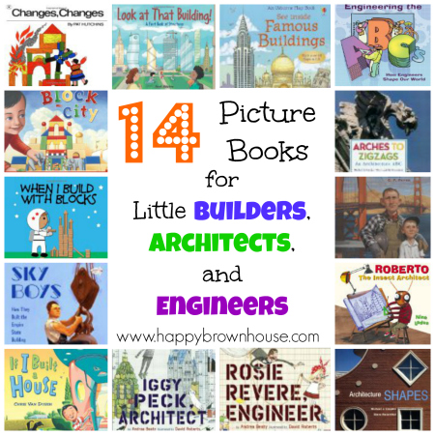

[http://assets.pinterest.com/images/pidgets/pin_it_button.png](http://www.pinterest.com/pin/create/button/?url=http://happybrownhouse.com/2013/10/12/14-picture-books-about-building-with-blocks-engineering-and-architecture/&media=http://happybrownhouse.com/wp-content/uploads/2013/10/14-Books-for-little-builders.jpg&description=14%20Picture%20Books%20for%20Little%20Builders,%20Architects,%20and%20Engineers)

[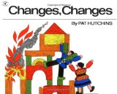](http://www.amazon.com/gp/product/0689711379/ref=as_li_ss_il?ie=UTF8&camp=1789&creative=390957&creativeASIN=0689711379&linkCode=as2&tag=happy04-20)http://ir-na.amazon-adsystem.com/e/ir?t=happy04-20&l=as2&o=1&a=0689711379  
[Changes, Changes](http://www.amazon.com/gp/product/0689711379/ref=as_li_ss_tl?ie=UTF8&camp=1789&creative=390957&creativeASIN=0689711379&linkCode=as2&tag=happy04-20)http://ir-na.amazon-adsystem.com/e/ir?t=happy04-20&l=as2&o=1&a=0689711379 by Pat Hutchins is a wordless book about a wooden couple that changes their building block house into other objects when the house catches on fire. It’s a clever little book that encourages children to tell the story in their own words.

[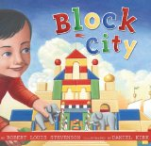](http://www.amazon.com/gp/product/0689869649/ref=as_li_ss_il?ie=UTF8&camp=1789&creative=390957&creativeASIN=0689869649&linkCode=as2&tag=happy04-20)http://ir-na.amazon-adsystem.com/e/ir?t=happy04-20&l=as2&o=1&a=0689869649  
[Block City](http://www.amazon.com/gp/product/0689869649/ref=as_li_ss_tl?ie=UTF8&camp=1789&creative=390957&creativeASIN=0689869649&linkCode=as2&tag=happy04-20)http://ir-na.amazon-adsystem.com/e/ir?t=happy04-20&l=as2&o=1&a=0689869649 by Robert Louis Stevenson is a book we were introduced to last year at our children’s museum when they had a building exhibit. The illustrations are beautiful!

[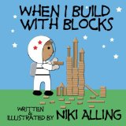](http://www.amazon.com/gp/product/1477535314/ref=as_li_ss_il?ie=UTF8&camp=1789&creative=390957&creativeASIN=1477535314&linkCode=as2&tag=happy04-20)http://ir-na.amazon-adsystem.com/e/ir?t=happy04-20&l=as2&o=1&a=1477535314  
[When I Build With Blocks](http://www.amazon.com/gp/product/1477535314/ref=as_li_ss_tl?ie=UTF8&camp=1789&creative=390957&creativeASIN=1477535314&linkCode=as2&tag=happy04-20)http://ir-na.amazon-adsystem.com/e/ir?t=happy04-20&l=as2&o=1&a=1477535314 by Niki Alling is a cute little book that appeals to little ones. The illustrations give little builders ideas for building–everything from outer space to oceans.

[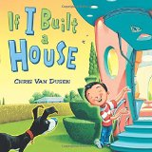](http://www.amazon.com/gp/product/0803737513/ref=as_li_ss_il?ie=UTF8&camp=1789&creative=390957&creativeASIN=0803737513&linkCode=as2&tag=happy04-20)http://ir-na.amazon-adsystem.com/e/ir?t=happy04-20&l=as2&o=1&a=0803737513  
[If I Built a House](http://www.amazon.com/gp/product/0803737513/ref=as_li_ss_tl?ie=UTF8&camp=1789&creative=390957&creativeASIN=0803737513&linkCode=as2&tag=happy04-20)http://ir-na.amazon-adsystem.com/e/ir?t=happy04-20&l=as2&o=1&a=0803737513 by Chris Van Dusen is a cute little book about the amazing things Jack would put in his dream house. I love the illustrations and there are plenty of blueprints and blocks throughout.

[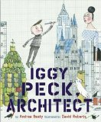](http://www.amazon.com/gp/product/081091106X/ref=as_li_ss_il?ie=UTF8&camp=1789&creative=390957&creativeASIN=081091106X&linkCode=as2&tag=happy04-20)http://ir-na.amazon-adsystem.com/e/ir?t=happy04-20&l=as2&o=1&a=081091106X  
[Iggy Peck, Architect](http://www.amazon.com/gp/product/081091106X/ref=as_li_ss_tl?ie=UTF8&camp=1789&creative=390957&creativeASIN=081091106X&linkCode=as2&tag=happy04-20)http://ir-na.amazon-adsystem.com/e/ir?t=happy04-20&l=as2&o=1&a=081091106X by Andrea Beaty is a funny little story of a budding architect. This one will make you and your kids giggle.

[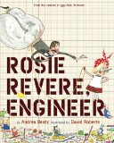](http://www.amazon.com/gp/product/B00E3AQS5E/ref=as_li_ss_il?ie=UTF8&camp=1789&creative=390957&creativeASIN=B00E3AQS5E&linkCode=as2&tag=happy04-20)http://ir-na.amazon-adsystem.com/e/ir?t=happy04-20&l=as2&o=1&a=B00E3AQS5E  
[Rosie Revere, Engineer](http://www.amazon.com/gp/product/B00E3AQS5E/ref=as_li_ss_tl?ie=UTF8&camp=1789&creative=390957&creativeASIN=B00E3AQS5E&linkCode=as2&tag=happy04-20)http://ir-na.amazon-adsystem.com/e/ir?t=happy04-20&l=as2&o=1&a=B00E3AQS5E by Andrea Beaty is about a little girl that secretly creates at night. Super cute! Perfect for girls!

[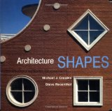](http://www.amazon.com/gp/product/0471143669/ref=as_li_ss_il?ie=UTF8&camp=1789&creative=390957&creativeASIN=0471143669&linkCode=as2&tag=happy04-20)http://ir-na.amazon-adsystem.com/e/ir?t=happy04-20&l=as2&o=1&a=0471143669  
[Architecture Shapes](http://www.amazon.com/gp/product/0471143669/ref=as_li_ss_tl?ie=UTF8&camp=1789&creative=390957&creativeASIN=0471143669&linkCode=as2&tag=happy04-20)http://ir-na.amazon-adsystem.com/e/ir?t=happy04-20&l=as2&o=1&a=0471143669 by Michael J. Crosbie is a counting book (1-10) that introduces preschoolers to shapes found in architecture.

[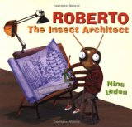](http://www.amazon.com/gp/product/0811824659/ref=as_li_ss_il?ie=UTF8&camp=1789&creative=390957&creativeASIN=0811824659&linkCode=as2&tag=happy04-20)http://ir-na.amazon-adsystem.com/e/ir?t=happy04-20&l=as2&o=1&a=0811824659  
[Roberto, The Insect Architect](http://www.amazon.com/gp/product/0811824659/ref=as_li_ss_tl?ie=UTF8&camp=1789&creative=390957&creativeASIN=0811824659&linkCode=as2&tag=happy04-20)http://ir-na.amazon-adsystem.com/e/ir?t=happy04-20&l=as2&o=1&a=0811824659 by Nina Laden is about a termite that wants to build with wood instead of eat it. Super cute with lots of puns for adults to enjoy while reading to kids.

[](http://www.amazon.com/gp/product/0810942186/ref=as_li_ss_il?ie=UTF8&camp=1789&creative=390957&creativeASIN=0810942186&linkCode=as2&tag=happy04-20)http://ir-na.amazon-adsystem.com/e/ir?t=happy04-20&l=as2&o=1&a=0810942186  
[Arches to Zigzags: An Architecture ABC](http://www.amazon.com/gp/product/0810942186/ref=as_li_ss_tl?ie=UTF8&camp=1789&creative=390957&creativeASIN=0810942186&linkCode=as2&tag=happy04-20)http://ir-na.amazon-adsystem.com/e/ir?t=happy04-20&l=as2&o=1&a=0810942186 by Michael J. Crosbie is a great way to introduce architecture vocabulary in an ABC book format. Another thing that I like about this book is that it is real-life pictures.

[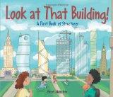](http://www.amazon.com/gp/product/1554536960/ref=as_li_ss_il?ie=UTF8&camp=1789&creative=390957&creativeASIN=1554536960&linkCode=as2&tag=happy04-20)http://ir-na.amazon-adsystem.com/e/ir?t=happy04-20&l=as2&o=1&a=1554536960  
http://ir-na.amazon-adsystem.com/e/ir?t=happy04-20&l=as2&o=1&a=1554536960  
[Look at That Building: A First Book of Structures](http://www.amazon.com/gp/product/1554536960/ref=as_li_ss_tl?ie=UTF8&camp=1789&creative=390957&creativeASIN=1554536960&linkCode=as2&tag=happy04-20)http://ir-na.amazon-adsystem.com/e/ir?t=happy04-20&l=as2&o=1&a=1554536960 by Scot Ritchie explores how a building is constructed, from foundations to roofing — then has a practice building for kids to create themselves.

[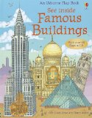](http://www.amazon.com/gp/product/0794523501/ref=as_li_ss_il?ie=UTF8&camp=1789&creative=390957&creativeASIN=0794523501&linkCode=as2&tag=happy04-20)http://ir-na.amazon-adsystem.com/e/ir?t=happy04-20&l=as2&o=1&a=0794523501  
[See Inside Famous Buildings (Usborne Flap Book)](http://www.amazon.com/gp/product/0794523501/ref=as_li_ss_tl?ie=UTF8&camp=1789&creative=390957&creativeASIN=0794523501&linkCode=as2&tag=happy04-20)http://ir-na.amazon-adsystem.com/e/ir?t=happy04-20&l=as2&o=1&a=0794523501 by Rob Lloyd Jones lets you discover and explore some of the world’s most famous buildings in a lift-the-flap book style. Super fun!

[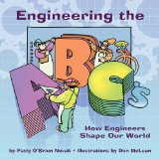](http://www.amazon.com/gp/product/1933916516/ref=as_li_ss_il?ie=UTF8&camp=1789&creative=390957&creativeASIN=1933916516&linkCode=as2&tag=happy04-20)http://ir-na.amazon-adsystem.com/e/ir?t=happy04-20&l=as2&o=1&a=1933916516  
[Engineering the ABC’s: How Engineers Shape Our World](http://www.amazon.com/gp/product/1933916516/ref=as_li_ss_tl?ie=UTF8&camp=1789&creative=390957&creativeASIN=1933916516&linkCode=as2&tag=happy04-20)http://ir-na.amazon-adsystem.com/e/ir?t=happy04-20&l=as2&o=1&a=1933916516 by Patty O’Brien Novak answers questions about how everyday things work and how engineering relates to so many parts of a child’s daily life.

[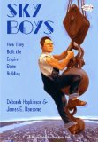](http://www.amazon.com/gp/product/0375865411/ref=as_li_ss_il?ie=UTF8&camp=1789&creative=390957&creativeASIN=0375865411&linkCode=as2&tag=happy04-20)http://ir-na.amazon-adsystem.com/e/ir?t=happy04-20&l=as2&o=1&a=0375865411  
[Sky Boys: How They Built the Empire State Building](http://www.amazon.com/gp/product/0375865411/ref=as_li_ss_tl?ie=UTF8&camp=1789&creative=390957&creativeASIN=0375865411&linkCode=as2&tag=happy04-20)http://ir-na.amazon-adsystem.com/e/ir?t=happy04-20&l=as2&o=1&a=0375865411 by Deborah Hopkinson is a beautifully illustrated book about the men that built the Empire State Building in the Depression Era. I really, really like this one!

[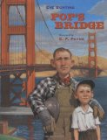](http://www.amazon.com/gp/product/0152047735/ref=as_li_ss_il?ie=UTF8&camp=1789&creative=390957&creativeASIN=0152047735&linkCode=as2&tag=happy04-20)http://ir-na.amazon-adsystem.com/e/ir?t=happy04-20&l=as2&o=1&a=0152047735  
[Pop’s Bridge](http://www.amazon.com/gp/product/0152047735/ref=as_li_ss_tl?ie=UTF8&camp=1789&creative=390957&creativeASIN=0152047735&linkCode=as2&tag=happy04-20)http://ir-na.amazon-adsystem.com/e/ir?t=happy04-20&l=as2&o=1&a=0152047735 by Eve Buntin is along the same lines as Sky Boys, but is about the building of the Golden Gate Bridge.

I hope this gives you some ideas for your little builder!  
[http://assets.pinterest.com/images/pidgets/pin_it_button.png](http://www.pinterest.com/pin/create/button/?url=http://happybrownhouse.com/2013/10/12/14-picture-books-about-building-with-blocks-engineering-and-architecture/&media=http://happybrownhouse.com/wp-content/uploads/2013/10/14-Books-for-little-builders.jpg&description=14%20Picture%20Books%20for%20Little%20Builders,%20Architects,%20and%20Engineers)

*This post is a part of the series,*[*31 Days of Open-Ended Play*](http://happybrownhouse.com/2013/10/01/31-days-of-open-ended-play/)*. Be sure to read all the posts in the series for more great ideas for encouraging learning and creativity through open-ended play.*